**PIZZA SALES SQL QUERIES :**

1. **Total Revenue :**

select round(sum(total_price),2) as Total_revenue from pizza_sales;

output :

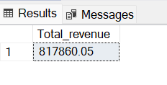

1. **Average Order value :**

select round(sum(total_price)/count(distinct order_id),2) as avg_ord from pizza_sales;

output :

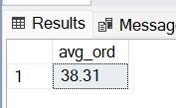

1. **Total pizza sold :**

select sum(quantity) as total_pizza_sold from pizza_sales;

output :

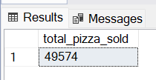

1. Total order Placed:

select count(distinct order_id) as total_order_placed from pizza_sales;

output :

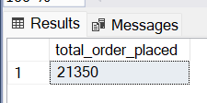

Average pizza per order :

select cast(cast(sum(quantity) as decimal(10,2))/cast(count(distinct order_id) as decimal(10,2)) as decimal(10,2)) as average_pizza

from pizza_sales;

output :

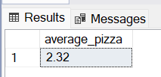

- charts requirements :

- Daily trend for total orders: to see day wise how many order is receiving.

select datename(DW, order_date) as order_day, count(distinct order_id) as total_orders

from pizza_sales group by DATENAME(DW,order_date);

output :

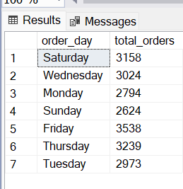

- Hourly trend for total orders

select DATEPART(hour, order_time) as order_hours, count(distinct order_id) as total_orders

from pizza_sales group by DATEPART(HOUR,order_time) order by DATEPART(HOUR,order_time);

output:

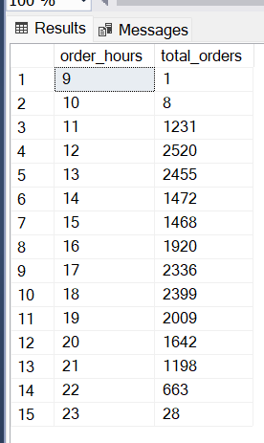

**-- Percentage of total sale:**

select pizza_category,sum(total_price) as total_sales, sum(total_price)*100/ (select sum(total_price) from pizza_sales) as percentage_total_sale_percat

from pizza_sales

group by pizza_category;

-- if you wnat to apply the month, quarter, week filters to the above queries you can use WHERE clause. Follow some of below example.

select pizza_category,sum(total_price) as total_sales, sum(total_price)*100/ (select sum(total_price) from pizza_sales where MONTH(order_date) = 1) as percentage_total_sale_percat

from pizza_sales

where MONTH(order_date) = 1

group by pizza_category;

-- here MONTH(order_date) = 1 indicates that the output is for the month of january, MONTH(order_date) = 4 indicates output for monthof april.

select pizza_category,sum(total_price) as total_sales, sum(total_price)*100/ (select sum(total_price) from pizza_sales where DATEPART(quarter, order_date) = 1

) as percentage_total_sale_percat

from pizza_sales

where DATEPART(quarter, order_date) = 1

group by pizza_category;

-- Here DATEPART(quarter, order_date) = 1 indicates that the output is for the quarter 1. DATEPART(quarter, order_date) = 3 indicates that the output is for the quarter 3.

- **Percentage of sales by Pizza size:**

select pizza_size,sum(total_price) as total_sales, cast(sum(total_price)*100/

(select sum(total_price) from pizza_sales) as decimal(10,2)) as percentage_total_sale_percat

from pizza_sales

group by pizza_size order by percentage_total_sale_percat desc;

-- **to chk quarter values :**

select pizza_size,cast(sum(total_price) as decimal(10,2)) as total_sales, cast(sum(total_price)*100/

(select sum(total_price) from pizza_sales where DATEPART(quarter,order_date)=1) as decimal(10,2))

as percentage_total_sale_percat

from pizza_sales

where DATEPART(quarter,order_date)=1

group by pizza_size order by percentage_total_sale_percat desc;

**-- Total Pizzas sold by pizza category:**

select pizza_category, sum(quantity) as total_pizza_quantitiy from pizza_sales group by pizza_category;

**-- Top 5 Best Sellers by Pizza Sold:**

select top 5 pizza_name, sum(quantity) as total_sold from pizza_sales group by pizza_name order by sum(quantity) desc;

**-- bottam 5 :**

select top 5 pizza_name, sum(quantity) as total_sold from pizza_sales group by pizza_name order by sum(quantity) asc;